Table of Contents
1. One router for 3 tiers application. 2
1.1 Client to access the appliacation 2
1.2 Virtual Server to access Internet 3
1.3 Conclusion 3
1.3.1 Advantage 4
1.3.2 Disadvantage 4
2. Two routers for 3 tiers application. 5
2.1 Client to access the appliacation 5
2.2 Virtual Server to access Internet 6
2.3 Conclusion 7
2.3.1 Advantage 7
2.3.2 Disadvantage ---many mannual operations needed. 7

1. One router for 3 tiers application.

1.1 Client to access the appliacation
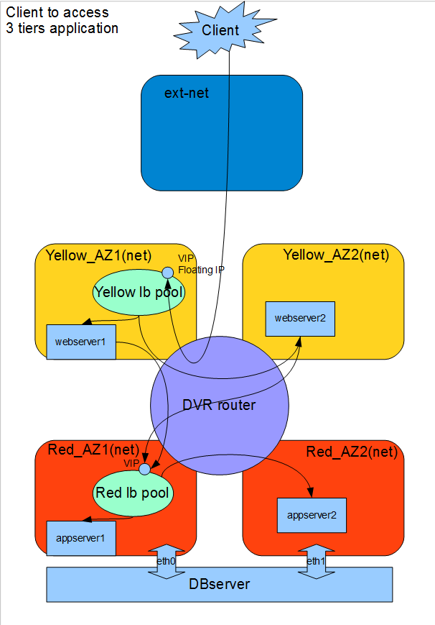

1.2 Virtual Server to access Internet

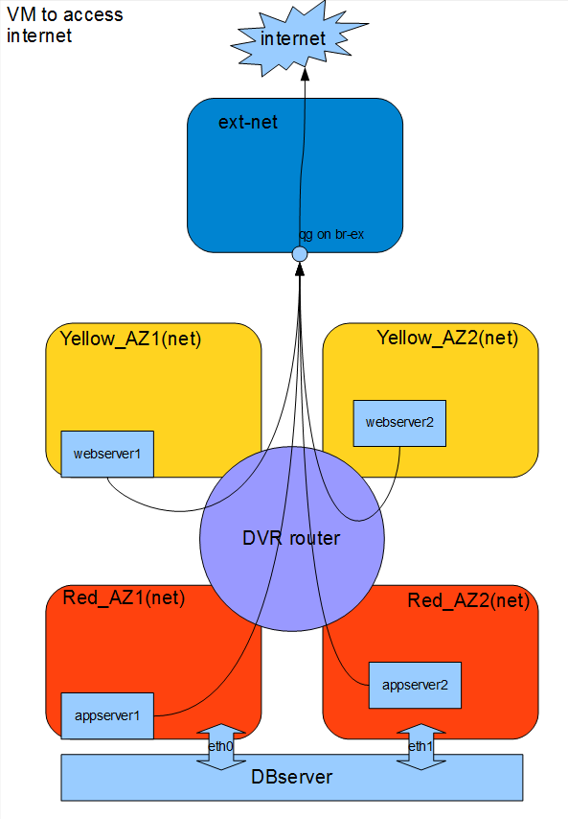
1.3 Conclusion
This solution is totally based on current neutron code. All networks connect to one DVR router, and use this DVR router to connect to internet.

1.3.1 Advantage
Simple

1.3.2 Disadvantage
      - SNAT of DVR can't be HA. If the host of SNAT is down, the DVR can't access internet.
      - All communication go through the DVR router. Can't meet the security requirement.

2. Two routers for 3 tiers application.

2.1 Client to access the appliacation
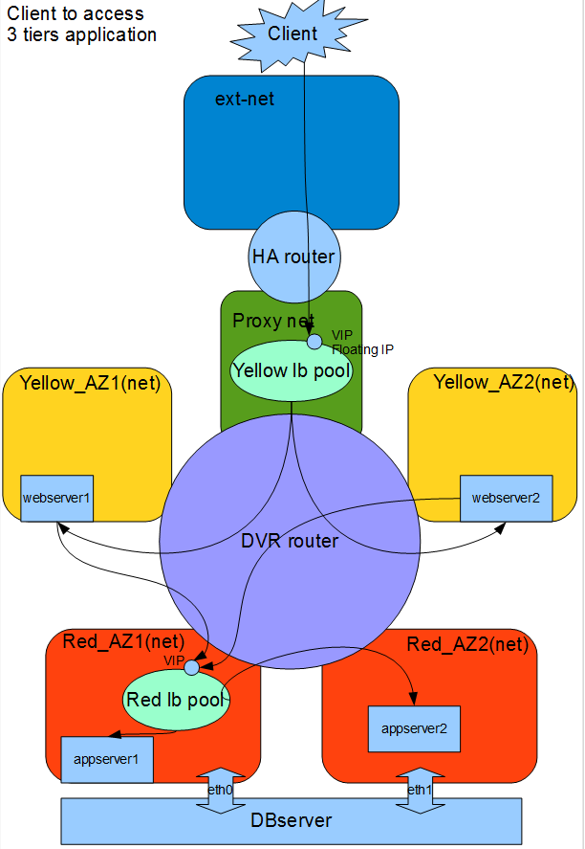

2.2 Virtual Server to access Internet
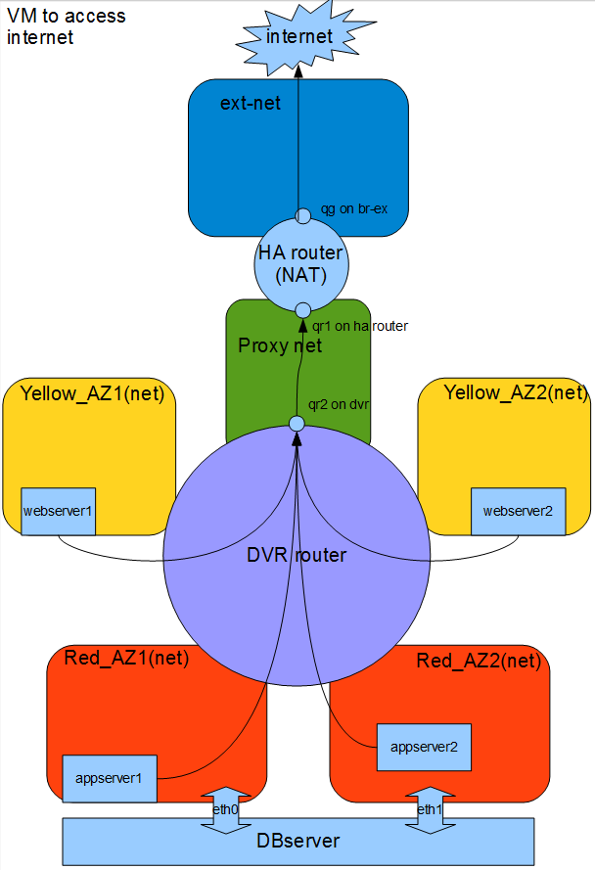

2.3 Conclusion
Current code of neutron can't achive this solution. Many mannual operations are needed. This solution use DVR router to hold East-West communication, and use HA router to hold North-South communication.

2.3.1 Advantage
      - Separate NS and EW communication. Can apply more security rules to the topology.
      - Use HA router to provide SNAT. So the SNAT can always work as long as there is at least one controller alive.

2.3.2 Disadvantage ---many mannual operations needed.
      - Add route to HA router to let the HA router know how to get to tenant networks such as yellow_az1.
      - Add default route to DVR router to let the vms know how to get the SNAT gateway.
      - Add route to lbaas namespace to let lbaas know how to get to the tenant network
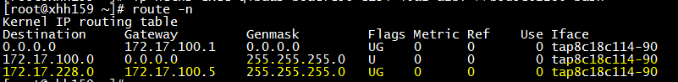
      - Change the flow rule on lbaas host to make the vip can get the right ha router qr
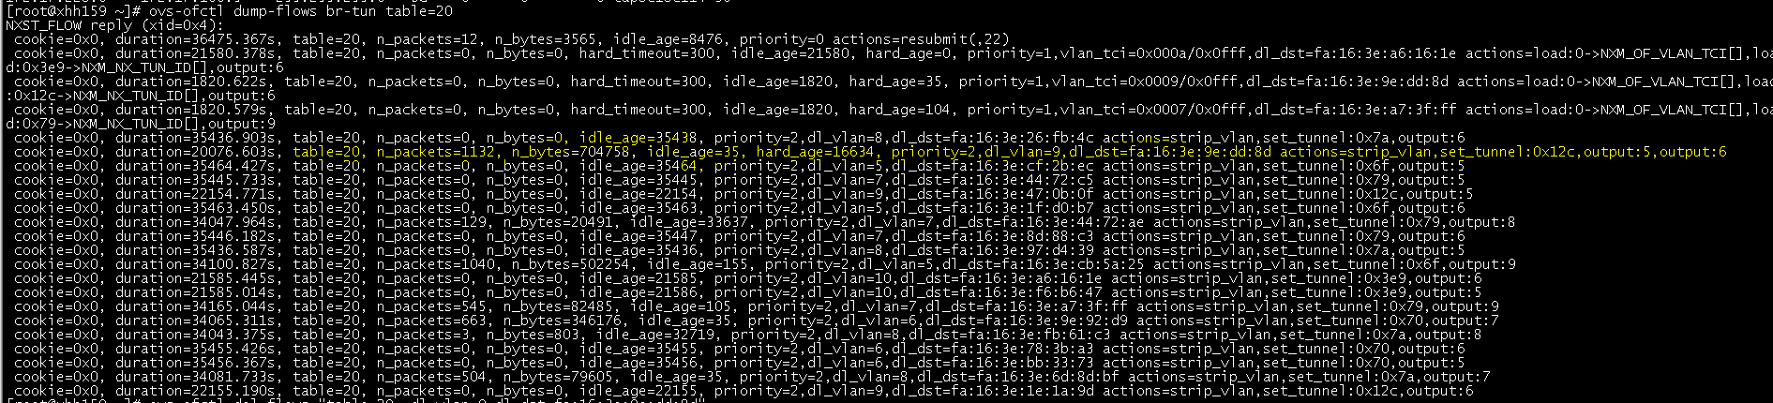
Because ha router might migrate between controllers, so the output port of this rule should be pointed to all other controller nodes.

Or, just delete this flow rule. This rule is created by dvr code. Deleting it will make the learning table be useful. You can see the learning table above.
      - Add neighbour table on lbaas namespace and ha router namespace to let them find each other.
Lbaas namespace:
ha router namespace:
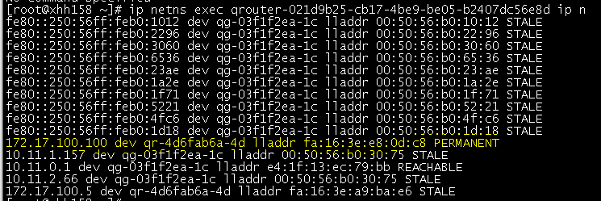
      - To make the vm be able to access the internet, Change the flow rule on compute host to make the vm can get the right ha router qr
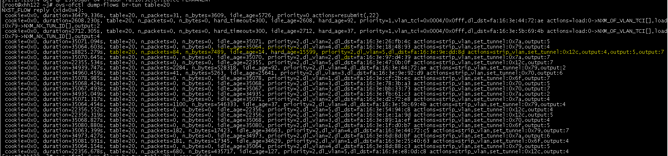
Or, just delete this flow rule. This rule is created by dvr code. Deleting it will make the package be sent to table22, which will multicast the package.
      - To make the vm be able to access the internet, add the neighbour table on compute host.
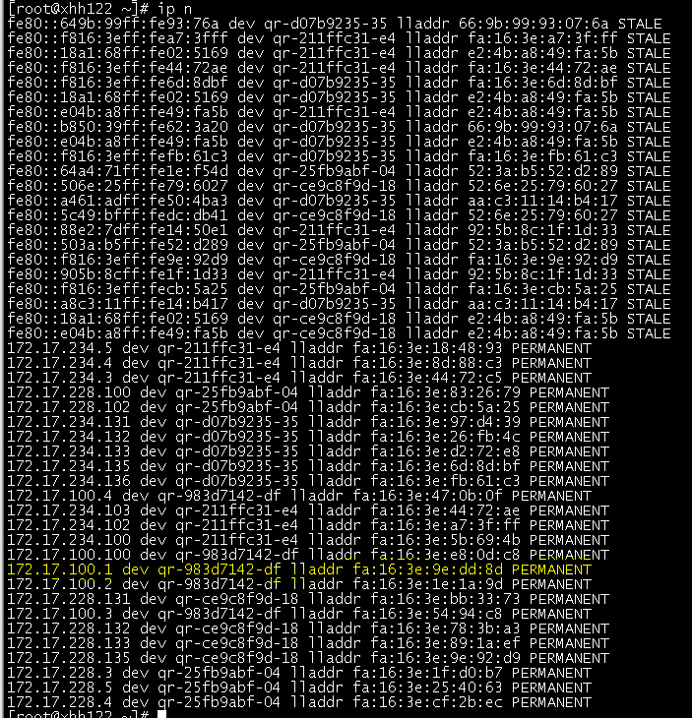
      - To make the vm be able to access the internet, add flows rules on every controller host to make the qr in ha router can get the package.

